Data Mining and Data Warehousing MCQ
1) Which of the following is an essential process in which the intelligent methods are applied to extract data patterns?
- Warehousing
- Data Mining
- Text Mining
- Data Selection

2) What is KDD in data mining?
- Knowledge Discovery Database
- Knowledge Discovery Data
- Knowledge Data definition
- Knowledge data house

3) For what purpose, the analysis tools pre-compute the summaries of the huge amount of data?
- In order to maintain consistency
- For authentication
- For data access
- To obtain the queries response
4) What are the functions of Data Mining?
- Association and correctional analysis classification
- Prediction and characterization
- Cluster analysis and Evolution analysis
- All of the above
5) In the following given diagram, which type of clustering is used?
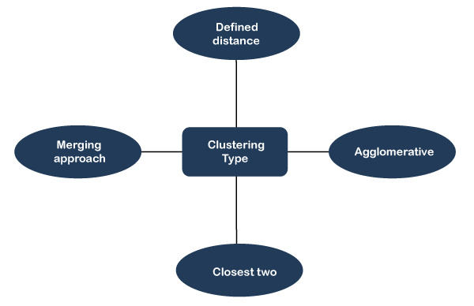
- Hierarchal
- Naive Bayes
- Partitional
- None of the above
6) Which of the following statements is incorrect about the hierarchal clustering?
- The hierarchal type of clustering is also known as the HCA
- The choice of an appropriate metric can influence the shape of the cluster
- In general, the splits and merges both are determined in a greedy manner
- All of the above
7) Which one of the following can be considered as the final output of the hierarchal type of clustering?
- A tree which displays how the close thing are to each other
- Assignment of each point to clusters
- Finalize estimation of cluster centroids
- None of the above

7) Which one of the following statements about the K-means clustering is incorrect?
- The goal of the k-means clustering is to partition (n) observation into (k) clusters
- K-means clustering can be defined as the method of quantization
- The nearest neighbor is the same as the K-means
- All of the above
8) Which of the following statements about hierarchal clustering is incorrect?
- The hierarchal clustering can primarily be used for the aim of exploration
- The hierarchal clustering should not be primarily used for the aim of exploration
- Both A and B
- None of the above
9) Which one of the clustering technique needs the merging approach?
- Partitioned
- Naïve Bayes
- Hierarchical
- Both A and C

10) Which of the following statement is true about the classification?
- It is a measure of accuracy
- It is a subdivision of a set
- It is the task of assigning a classification
- None of the above
11) Which of the following statements is correct about data mining?
- It can be referred to as the procedure of mining knowledge from data
- Data mining can be defined as the procedure of extracting information from a set of the data
- The procedure of data mining also involves several other processes like data cleaning, data transformation, and data integration
- All of the above

12) Which one of the following statements is not correct about the data cleaning?
- It refers to the process of data cleaning
- It refers to the transformation of wrong data into correct data
- It refers to correcting inconsistent data
- All of the above

13) Which one of the following refers to the binary attribute?
- This takes only two values. In general, these values will be 0 and 1, and they can be coded as one bit
- The natural environment of a certain species
- Systems that can be used without knowledge of internal operations
- All of the above

14) Euclidean distance measure is can also defined as ___________
- The process of finding a solution for a problem simply by enumerating all possible solutions according to some predefined order and then testing them
- The distance between two points as calculated using the Pythagoras theorem
- A stage of the KDD process in which new data is added to the existing selection.
- All of the above

15) Which one of the following can be considered as the correct application of the data mining?
- Fraud detection
- Corporate Analysis & Risk management
- Management and market analysis
- All of the above

16) Which of the following also used as the first step in the knowledge discovery process?
- Data selection
- Data cleaning
- Data transformation
- Data integration

17) Which of the following is generally used by the E-R model to represent the weak entities?
- Diamond
- Doubly outlined rectangle
- Dotted rectangle
- Both B & C

18) The term "DMQL" stands for _____
- Data Marts Query Language
- DBMiner Query Language
- Data Mining Query Language
- None of the above
19)……… is not associated with data cleaning process.
Select one:
Deduplication
Domain consistency
Segmentation
Disambiguation
20)___________ is a good alternative to the star schema.
A. Star schema.
B. Snowflake schema.
C. Fact constellation.
D. Star-snowflake schema
21)A star schema has what type of relationship from a dimension to the fact table? S
elect one
: Many-to-many
Many-to-one
One-to-one
One-to-many
22) Expansion for DSS in DW is Select one:
Decisive Strategic System
Data Support System
Data Store System
Decision Support system
23) Data warehouse contains ________data that is seldom found in the operational environment
Select one:
informational
normalized
denormalized
summary
24) The extract process is _______ Select one:
capturing a subset of the data contained in operational systems
capturing a subset of the data contained in various decision support systems
capturing all of the data contained in various decision support systems
capturing of the data contained in all operational systems
25) A fact table in the centre with dimension tables directly linked to it
Select one:
A star schema
A starflake schema
A snowflake schema
A constellation

